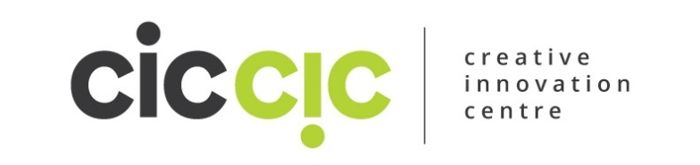
Creative Innovation Centre CIC –Provider, Tutor or Public Event Guest Blog Form.
If you have provided an event or workshop at CICCIC then you are also invited to become a guest blog writer. This means we can publish your advice or information article free of charge and promote your business, name or event. To ensure that we can publish and promote the blog correctly and optimumly we ask that you fill in the form below and return to us with any images you have legally obtained and a photo of you (where applicible).
Please send images, logo or photos when sending this form to us. Send to info@ciccic.co.uk
Title of Blog (make it tempting, tasty, sexy, straight to the point or offer a compelling offer or have a title that captures peoples attention)
Your Name, Business & Biography (short or long or both)
Blog Article (by submitting this to us you confirm that this article does not infringe on any copyright)
Links associated with your blog (e.g. could be outsource or organisation you have referred to)
Your website Link & Email Address
Your Social Media, Links & Additional Info (please add your social media URL’s, you tube videos links, web address and anything else that you feel is relevant)

